

Data Technician

Name: Milla Freeman
Course Date: 10/11/2025
Table of contents
Day 1: Task 1 4
Day 2: Task 1 4
Day 2: Task 2 5
Day 4: Task 1 6
Day 4: Task 2 6
Day 4: Task 3 7
Course Notes 7
Python Additonal Resources 8
Exercise 1: You can either complete training on this website. 8
Exercise 2: Complete exercise on Google Colab and share your notebook with the trainer. 8
Exercise 3: Complete exercise on Google Colab and share your notebook with the trainer. 9
Exercise 4: Challenge yourself on hackerrank. Solve Python | HackerRank 9
Exercise 5: Practice on CodingChef. Print Coding Chef Question in Python 9
Exercise 6: Kaggle Data Visualization: Learn Data Visualization | Kaggle 9
Exercise 7: Kaggle Pandas Tutorial: Learn Pandas | Kaggle 10
Exercise 8: Video: Learn Pandas in Under 3 Hours | Filtering, Joins, Indexing, Data Cleaning, Visualizations - YouTube 10

How to Share your notebook
- Select share
- Enter and add trainers’ email yusufs@justit.co.uk
- Make sure that you set General access to Anyone with the link.
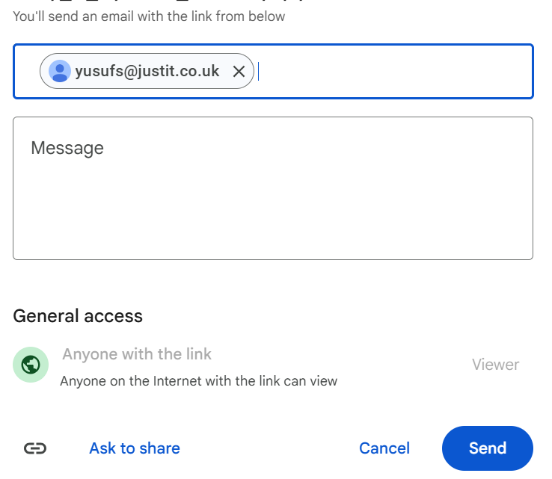
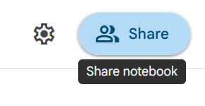
- Press send.

Day 1: Task 1
- Follow below link. https://colab.research.google.com/drive/1X2y7wcJ768lPnnq4HEOK2hpeefz3Bzl5?usp=sharing
- Save a copy of this notebook in your Drive and rename by adding your name to the end.
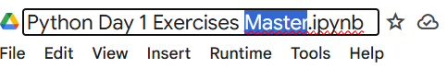

- Go through the notebook and complete the exercises at the end.
- Share your notebook with your trainer.

Day 2: Task 1
- Follow below link.
- https://colab.research.google.com/drive/1FMs6Dqg_tTSqn0wAuTa0aTX_vkYwkEJMusp=sharing
- Save a copy of this notebook in your Drive and rename by adding your name to the end.
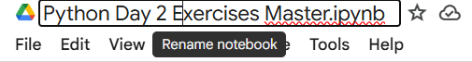

- Go through the notebook and complete the exercises at the end.
- Share your notebook with your trainer.

Day 2: Task 2

It is a common software development interview question to create the below with a certain programming language. Create the below using Python syntax, test it and past the completed syntax and output below.

FizzBuzz:

Go through the integers from 1 to 100.
If a number is divisible by 3, print "fizz."
If a number is divisible by 5, print "buzz."
If a number is both divisible by 3 and by 5, print "fizzbuzz."
Otherwise, print just the number.
Use loops and if statements.

Paste your completed work to the right

Day 4: Task 1

- Follow below link. https://colab.research.google.com/drive/1ZLG3LgzHUgYfVlLzs8W2OpBugHWRBTKP?usp=sharing
- Save a copy of this notebook in your Drive and rename by adding your name to the end.

- Go through the notebook and complete the exercises at the end.
- Share your notebook with your trainer.

Day 4: Task 2
- Follow below link. https://colab.research.google.com/drive/1OIlNFt7vYRuikgRUw8HemN543jdeM8lM?usp=sharing
- Save a copy of this notebook in your Drive and rename by adding your name to the end.
- Download the dataset here. https://drive.google.com/file/d/14Yz-06ykP-KL-lKFFckqfJk2jVm59zY4/view?usp=sharing
- Go through the notebook and complete the exercises at the end.
- Share your notebook with your trainer.

Day 4: Task 3
- Follow below link. https://colab.research.google.com/drive/1SzWwpS86Eju3tp_EDpBKFmYqFseWVam_?usp=sharing
- Save a copy of this notebook in your Drive and rename by adding your name to the end.
- Download the dataset here. https://drive.google.com/file/d/1FSo51F-FDXoj7mQQoKY8tk6iFg2l6YiJ/view?usp=sharing
- Go through the notebook and complete the exercises at the end.
- Share your notebook with your trainer.

Course Notes

It is recommended to take notes from the course, use the space below to do so, or use the revision guide shared with the class:

Python Additonal Resources

Exercise 1: You can either complete training on this website.
Free Python Course by Cisco: No Prior Experience Necessary! (highly recommended, free course. Certification upon completion.)
Or complete other exercises.

Exercise 2: Complete exercise on Google Colab and share your notebook with the trainer.
- Write a Python program to print "Hello, World!"
print(“Hello, World!”)
- Write a Python program to calculate the sum of two numbers entered by the user.
num1 = float(input(“Enter the first number: “))
num2 = float(input(“Enter the second number: “))

sum = num1 + num2

print(“The sum of the two numbers is:”, sum)
- Write a Python program to convert temperature entered by user from Celsius to Fahrenheit.
celsius = float(input(“Enter temperature in Celsius: “))

fahrenheit = (celsius * 9/5) + 32

print(f”{celsius} °C is equal to {fahrenheit} °F”)
- Write a Python program to calculate the area of a rectangle given its length and width
length = float(input(“Enter the length of the rectangle: “))
width = float(input(“Enter the width of the rectangle: “))

area = length * width

print(f”The area of the rectangle is: {area}”)
- Create a program that takes a user's name and age as input and prints a greeting message
name = input(“Enter your name: “)
age = input(“Enter your age: “)

print(f”Hello, {name}! You are {age} years old.”)
- Write a program to check if a number is even or odd
number = int(input(“Enter a number: “))

if number % 2 == 0:
print(f”{number} is even.”)
else:
print(f”{number} is odd.”)
- Given a list of numbers, find the maximum and minimum values
numbers = list(map(float, input(“Enter a list of numbers separated by spaces: “).split()))

print(“Maximum:”, max(numbers))
print(“Minimum:”, min(numbers))
- Create a Python function to check if a given string is a palindrome
text = input(“Enter a word: “)

if text == text [:: -1]:
print(“It’s a palindrome!”)
else:
print(“It’s not a palindrome.”)
- Calculate the compound interest for a given principal amount, interest rate, and time period
principal = float(input(“Enter the principal amount: “))
rate = float(input(“Enter the annual interest rate (in %): “))
time = float(input(“Enter the time period (in years):”))

amount = principal * (1 + rate / 100) ** time
compound_interest = amount – principal

print(f”The compound interest is: {compound_interest}”)
print(f”The total amount after {time} years is: {amount}”)
- Write a program that converts a given number of days into years, weeks, and days
days = int(input(“Enter number of days: “))

years = days // 365
weeks = (days % 365) // 7
remaining_days = (days % 365) % 7

print(f”{days} days = {years} years(s), {weeks} week(s), and {remaining_days} day(s)”)
- Given a list of integers, find the sum of all positive numbers
nums = list(map(int, input(“Enter integers: “).split()))

positive_sum = sum(n for n in nums if n > 0)

print(“Sum of positive numbers:”, positive_sum)
- Create a program that takes a sentence as input and counts the number of words in it
sentence = input(“Enter a sentence: “)

words = sentence.split()

word_count = len(words)

print(f”The number of words in the sentence is: {word_count}”)
- Write a program to check if a number is prime.
num = int(input(“Enter a number: “))

if num <=1:
print(“Not a prime number.”)
else:
is_prime = True
for i in range(2, num):
if num % i == 0:
is_prime = False
break

if is_prime:
print(“Prime number.”)
else:
print(“Not a prime number.”)
- Write a program that checks if a given number is positive, negative, or zero.
num = float(input(“Enter a number: “))

if num > 0:
print(“The number is positive.”)
elif num < 0:
print(“The number is negative.”)
else:
print(“The number is zero.”)
- Create a loop that prints the first 10 even numbers.
for i in range (2, 21, 2):
print (i)
- Implement a program that finds the largest number in a list.
numbers = list(map(float, input(“Enter numbers separated by spaces: “).split()))

largest = max(numbers)

print(f”The largest number is: {largest}”)
- Create a program that takes a year as input and checks if it is a leap year or not
year = int(input(“Enter a year: “))

if (year % 4 == 0 and year % 100 != 0) or (year % 400 == 0):
print(f”{year} is a leap year.”)
Else:
Print(f”{year} is not a leap year.”)
- Calculate the sum of digits of a given number.
num = int(input(“Enter a number: “))

total = 0
while num > 0:
total += num % 10
num // = 10

print(“Sum of digits:”, total)
- Create a program that checks if a given string is a palindrome.
text = input(“Enter a word: “)

if text == text [:: -1]:
print(“It’s a palindrome!”)
else:
print(“It’s not a palindrome.”)

Exercise 3: Complete exercise on Google Colab and share your notebook with the trainer.
You are going to use the different Python concepts seen to build a program that will simulate the behaviour of an ATM. Follow the instructions below:
Print a main menu to ask the user different options for displaying the bank account balance, for depositing money, to withdraw money, and to exit from the ATM. Ideally create a function for each menu option to be executed. Use conditional statements for asking the user the different menu options.
Additional (optional): Ask the user a PIN to access to the ATM menu once the PIN is correct otherwise ask the user to try again.
Prompt the user to enter an option:
  - If ‘1’ is entered, display the current balance and return to main menu.
  - If ‘2’ is entered, print a sub-menu with different withdrawal amounts (give also a choice for “other amount’ to let the user enter an amount) :
  - Check that the requested withdrawal is allowed, print a message to show that the money has been withdrawn, calculate the new balance and return to main menu.
  - If ‘other_amount’ is selected, then prompt the user for an integer value. Check this number is a multiple of 10 and that the withdrawal is permitted, print a message to show that the money has been withdrawn, calculate the new balance and return to main menu.
- If ‘exit’ is selected print a goodbye message and exit (break).
- If another value is entered, print an error message and print the menu again.

-Re-use the ATM menu options across the program to ask the user if he/she would like to perform another operation on the bank account.

Exercise 4: Challenge yourself on hackerrank. Solve Python | HackerRank

Exercise 5: Practice on CodingChef. Print Coding Chef Question in Python

Exercise 6: Kaggle Data Visualization: Learn Data Visualization | Kaggle

Exercise 7: Kaggle Pandas Tutorial: Learn Pandas | Kaggle

Exercise 8: Video: Learn Pandas in Under 3 Hours | Filtering, Joins, Indexing, Data Cleaning, Visualizations - YouTube

We have included a range of additional links to further resources and information that you may find useful, these can be found within your revision guide.

END OF WORKBOOK

Please check through your work thoroughly before submitting and update the table of contents if required.

Please send your completed work booklet to your trainer.

